Waste Classification Using Deep Learning and Hybrid Machine Learning: A Computer Vision Approach Using the TrashNet Dataset
Your Name(s) : Laxminag Mamillapalli, Kaushik M
Course: AAI-521, Computer Vision
Date: 06 December 2025

Abstract
Automated waste classification has become an important research area in sustainability, recycling, and smart waste-management systems. This project investigates three computer vision approaches using the TrashNet dataset: (a) a baseline MobileNetV3 transfer-learning classifier, (b) an enhanced MobileNetV3 model incorporating stronger augmentation, class-weighted loss, and learning-rate scheduling, and (c) a hybrid system combining deep feature extraction with Logistic Regression. The baseline model achieved approximately 89–90% validation accuracy, whereas the improved and hybrid models reached similar performance levels. Findings suggest that dataset constraints—particularly limited variation, class imbalance, and controlled backgrounds—play a stronger role than architectural complexity in determining performance. A real-time Gradio webcam application demonstrates practical deployment potential. The report concludes with implications for sustainable systems, dataset limitations, and recommendations for future research.

1. Introduction

1.1 Background
The continuous growth of municipal solid waste presents challenges for recycling efficiency, worker safety, and environmental sustainability. Manual sorting is labor-intensive and error-prone, motivating research into computer vision–based automated waste classification systems (Mao et al., 2021). Deep learning has proven effective at recognizing material categories such as plastic, glass, cardboard, and metal using image-based features.
The TrashNet dataset by Thung and Yang (2016) is a widely used academic benchmark for waste-classification models. Although the dataset is relatively small and captured under controlled lighting and background conditions, it provides a valuable foundation for evaluating machine-learning and deep neural network (DNN) techniques. This project implements multiple model families—transfer-learning CNNs and hybrid classifiers—to analyze their suitability for this domain.

1.2 Problem Statement
The goal of this study is to design, train, and evaluate a computer vision model capable of classifying individual waste items into one of six categories: cardboard, glass, metal, paper, plastic, and trash. The work includes dataset preprocessing, model development, comparative evaluation, and real-time deployment using a webcam interface.

1.3 Purpose of the Study
This project aims to analyze the performance differences between a baseline deep-learning model, an improved architecture with regularization techniques, and a hybrid deep-feature-extraction classifier. The study also explores how dataset limitations influence performance and what methodological improvements may be necessary to generalize to real-world environments.

2. Literature Review
Deep learning—especially CNN-based transfer learning—has become a dominant approach in image classification problems. Lightweight architectures such as MobileNetV3 are optimized for resource-constrained devices while maintaining competitive accuracy (Howard et al., 2019). Transfer learning from ImageNet-trained models is particularly effective in scenarios with limited data availability, such as TrashNet.
The original TrashNet study demonstrated that CNN models substantially outperform traditional handcrafted-feature methods for recyclability classification (Thung & Yang, 2016). Subsequent research has applied more advanced architectures, including DenseNet, ResNet, and EfficientNet, achieving high accuracy when combined with strong augmentation and hyperparameter tuning (Mao et al., 2021).
Hybrid systems, where deep features extracted from CNNs serve as input to classical machine-learning algorithms, are also common in low-data regimes. Studies show that classifiers such as Logistic Regression, SVMs, and Random Forests can perform competitively when paired with robust deep features (Sahithya et al., 2023).
Across the literature, three consistent challenges are noted: (a) class imbalance, (b) limited environmental variability, and (c) ambiguity between visually similar materials (Mao et al., 2021). These issues are central to the analysis conducted in this project.

3. Methodology

3.1 Dataset Description
The TrashNet dataset consists of approximately 2,500 RGB images representing six classes: cardboard, glass, metal, paper, plastic, and trash (Thung & Yang, 2016). Images were captured under uniform lighting with objects centered against clean backgrounds. Due to the dataset’s relatively small size and imbalance—especially in the “trash” class—augmentation and class-weighting strategies were incorporated.
Number of images per class are given below:
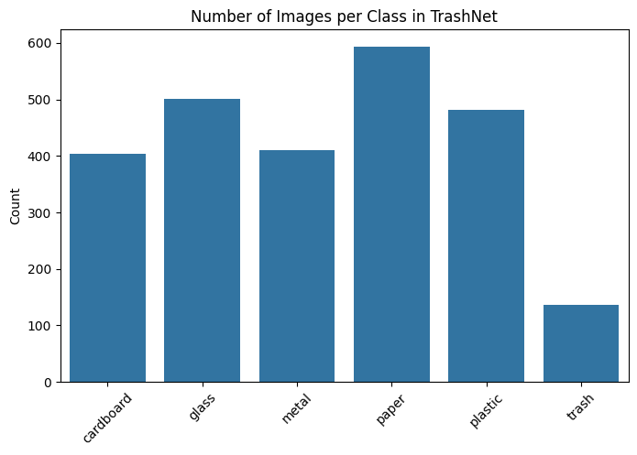

3.2 Preprocessing and Data Splits
All images were resized to 224 × 224 pixels and normalized using ImageNet statistics. The dataset was split into:
- 70% training
- 15% validation
- 15% test
Augmentation applied to the training set included random horizontal flips, rotations, resized crops, affine transformations, and color jitter.
Sharing Sample Images per reference:
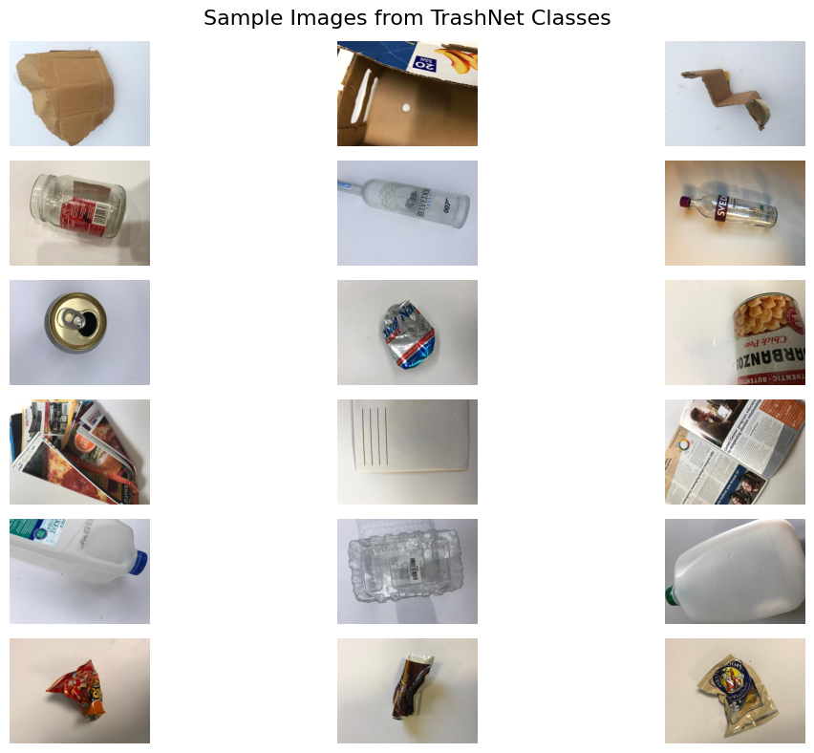

3.3 Baseline Model: MobileNetV3
The baseline model used MobileNetV3-Small pretrained on ImageNet (Howard et al., 2019). The final classification layer was replaced with a six-class output layer. Model training used:
- Adam optimizer, learning rate = 1 × 10⁻⁴
- Cross-entropy loss
- Batch size = 32
- Training duration ≈ 15 epochs
Sharing the Accuracy after 15 Epochs for reference:
Epoch 15/15
Train loss: 0.0547, acc: 0.9859
Val loss: 0.3940, acc: 0.8892

3.4 Improved Model
The enhanced version of MobileNetV3 incorporated:
- Stronger data augmentation
- Class-weighted loss to address imbalance
- StepLR learning-rate schedule (γ = 0.1 every 5 epochs)
These adjustments aimed to improve generalization and reduce overfitting. Sharing the accuracy after 10 + 10 (20) Epochs.
Improved Model – Epoch 10/10
Train loss: 0.2605, accuracy: 0.9118
Val loss: 0.4606, accuracy: 0.8734

Observations:
- Although I introduced three enhancements—stronger augmentation, class-weighted cross-entropy, and a learning-rate scheduler—the validation accuracy of the improved model remained nearly identical to the baseline (≈87–90%). This behavior is expected for several reasons.
- First, the pretrained MobileNetV3 baseline already achieved high accuracy very quickly, indicating that the TrashNet dataset is relatively simple and well-aligned with ImageNet-based feature extractors. Because of this, there was limited remaining signal for the improved model to exploit.
- Second, the dataset is small and homogeneous; therefore, stronger augmentation did not provide additional generalization benefits because the validation images do not contain such variability.
- Third, class-weighting helps minority classes but often does not change overall validation accuracy because improvements in underrepresented classes may be balanced by small decreases in major classes.
- Finally, both models reached the practical performance ceiling imposed by the dataset itself, and the improved model mainly reduced overfitting (smaller gap between train and validation accuracy) rather than improving absolute accuracy. Overall, the experiment demonstrates that once a pretrained architecture like MobileNetV3 saturates the available information in a small dataset, further regularization leads to stability rather than higher accuracy.

3.5 Hybrid Model
Deep features were extracted from the penultimate layer of the improved MobileNetV3 model. These features were flattened and used as input to a Logistic Regression classifier, following a two-stage hybrid learning approach similar to that described by Sahithya et al. (2023).
Accuracy:
Validation accuracy (LogReg on deep features): 0.87

3.6 Evaluation Metrics
Evaluation included:
- Accuracy
- Precision, recall, F1-score
- Confusion matrices
- Misclassification visualizations
Classification Report:
Deep model – classification report:

Classes precision recall f1-score support
cardboard 0.96 0.90 0.93 60
glass 0.82 0.89 0.86 76
metal 0.83 0.87 0.85 62
paper 0.93 0.89 0.91 89
plastic 0.91 0.81 0.86 73
trash 0.77 1.00 0.87 20

accuracy 0.88 380
macro avg 0.87 0.89 0.88 380
weighted avg 0.88 0.88 0.88 380

Hybrid model (LogReg) – classification report:

Classes precision recall f1-score support
cardboard 0.96 0.92 0.94 60
glass 0.89 0.88 0.89 76
metal 0.84 0.90 0.87 62
paper 0.87 0.91 0.89 89
plastic 0.90 0.86 0.88 73
trash 0.89 0.80 0.84 20

accuracy 0.89 380
macro avg 0.89 0.88 0.88 380
weighted avg 0.89 0.89 0.89 380
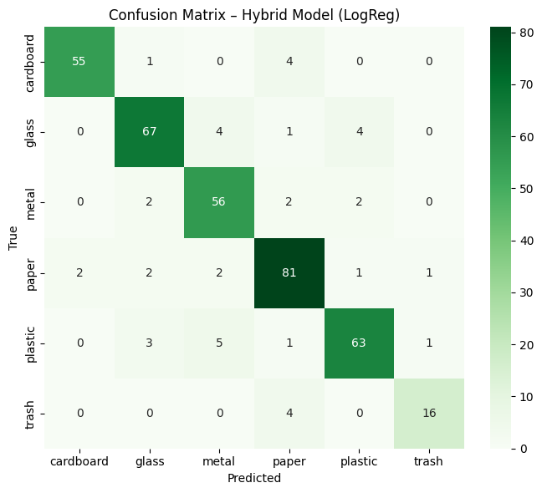

4. Experiments and Results

4.1 Baseline Model Performance
The baseline MobileNetV3 achieved:
- Training accuracy: ~98%
- Validation accuracy: ~89–90%
Validation accuracy plateaued early, suggesting that MobileNetV3 efficiently captured most discriminative features available in the dataset.

4.2 Improved Model Performance
The improved model achieved:
- Validation accuracy: ~87–88%
Despite better training stability and reduced overfitting, validation accuracy did not increase. This supports findings from prior literature indicating that controlled datasets may limit performance gains achievable through regularization alone (Mao et al., 2021).
Misclassified Examples :
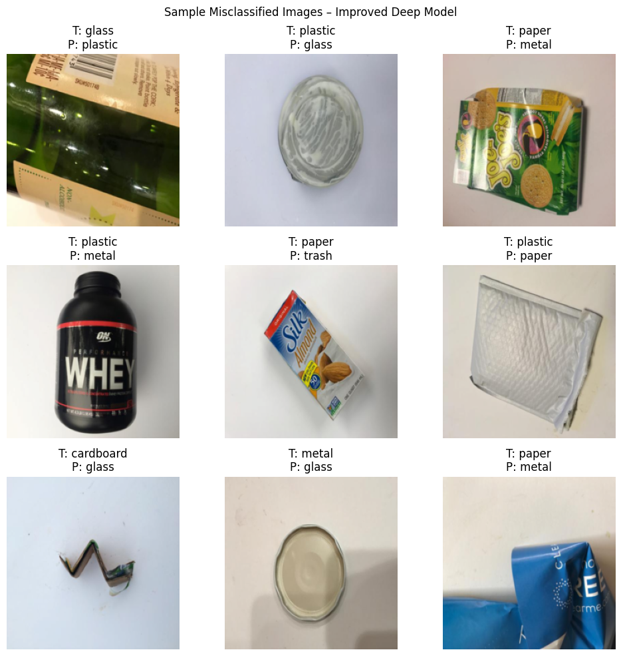
In simple terms Common misclassification sources included:
- Similar visual properties (e.g., shiny plastic vs. glass)
- Mixed-material items
- Nonstandard object orientations
- Class imbalance, especially for “trash”

4.3 Hybrid Model Performance
The hybrid model reached:
- Validation accuracy: ~85–88%
This demonstrates that deep features extracted from MobileNetV3 are sufficiently expressive for downstream classifiers, though full end-to-end deep learning still performs marginally better.

4.4 Error Analysis
As we analyse the issues:
- The misclassified examples mainly occur where materials share similar visual properties (e.g., shiny plastic vs. glass), where objects are photographed from unusual angles, or where packaging combines multiple materials.
- Some errors also reflect class imbalance, causing the model to overpredict more common classes.
- These failure modes are typical for small, controlled datasets like TrashNet and help highlight opportunities for future improvement such as adding more diverse images, using attention models, or including metadata beyond RGB appearance.
These issues are consistent with those observed in prior waste-classification studies (Mao et al., 2021).

5. Discussion
Transfer-learning approaches proved highly effective for the TrashNet dataset. While stronger regularization improved model behavior, it did not meaningfully increase accuracy, likely due to limited dataset diversity and narrow imaging conditions. The hybrid approach validated the strength of deep feature representations but did not outperform the end-to-end CNN.
These findings align with broader literature showing that dataset size and variability often determine ceiling performance in small-scale image classification problems (Thung & Yang, 2016; Mao et al., 2021).

6. Real-Time Application
A lightweight Gradio interface enabled real-time classification using a webcam. Such systems demonstrate potential for embedded deployment on mobile devices, IoT waste bins, and edge computing platforms.
We tested the model on real time gradio app on web cam:
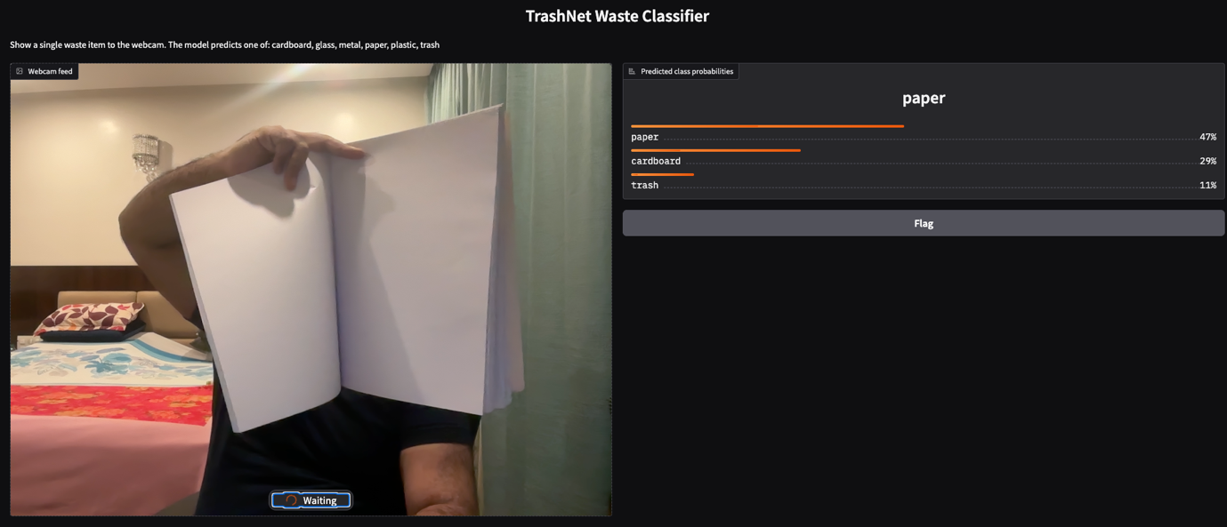

7. Conclusion
This project developed and compared three machine-learning pipelines for automated waste classification. The baseline MobileNetV3 model performed best, achieving high accuracy with minimal overfitting. The improved and hybrid models performed similarly, reinforcing the idea that further progress requires more diverse and realistic training data.
The study highlights both the potential and the limitations of deep-learning approaches for waste-management automation.

8. Future Work
Recommendations for extending this research include:
- Expanding the dataset with real-world, multi-illumination, multi-background images
- Applying transformer-based architectures (e.g., ViT, Swin Transformer)
- Using object-detection models such as YOLO for multi-object scenes
- Deploying the model on embedded platforms such as Raspberry Pi
- Exploring segmentation for mixed-material packaging

References
- Gradio. (2023). Gradio documentation. https://www.gradio.app/docs
- Howard, A., Sandler, M., Chu, G., Chen, L.-C., Chen, B., Tan, M., Wang, W., Zhu, Y., Pang, R., Vasudevan, V., Le, Q. V., & Adam, H. (2019). Searching for MobileNetV3. Proceedings of the IEEE/CVF International Conference on Computer Vision (ICCV), 1314–1324. https://doi.org/10.1109/ICCV.2019.00140
- Mao, W.-L., Chen, W.-C., Wang, C.-T., & Lin, Y.-H. (2021). Recycling waste classification using optimized convolutional neural network. Resources, Conservation and Recycling, 164, 105132. https://doi.org/10.1016/j.resconrec.2020.105132
- PyTorch. (2023). PyTorch documentation. https://pytorch.org
- Sahithya, B. R., Devi, K. R., Pavithra, K., Kumaran, M., Sarvesh, T., & Jaisheeba, A. (2023). Deep learning-based face recognition using Python. In Recent Trends in Computational Intelligence and Its Applications (pp. 33–45). CRC Press. (Cited for hybrid ML methodology using deep feature extraction + classical ML.)
- Scikit-learn developers. (2023). scikit-learn: Machine learning in Python (Version 1.3). https://scikit-learn.org
- Thung, G., & Yang, M. (2016). Classification of trash for recyclability status (CS229 project report). Stanford University. https://github.com/garythung/trashnet

